# [**'Magnum P.I.' Gives Higgins a Shot at Love in Season 3**](https://www.tvinsider.com/953536/magnum-pi-season-3-jay-ali-ethan-shah/)

[***Meredith Jacobs***](https://www.tvinsider.com/author/meredith-jacobs/)5 HOURS AGO

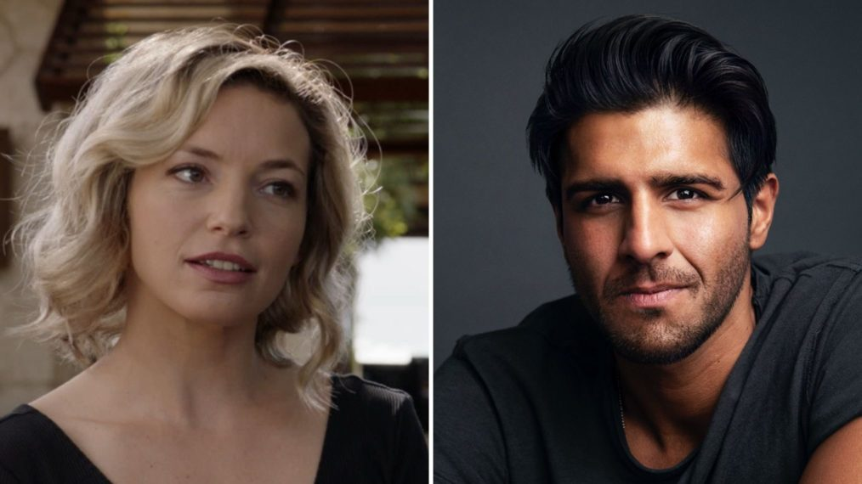

##### EXCLUSIVE

CBS; Corey Nickols

Love comes to the island in Season 3.

Jay Ali ([***Daredevil***](http://tvinsider.com/show/daredevil)) will recur on [***Magnum P.I.***](http://tvinsider.com/show/magnum-p-i) as a new love interest for Juliet Higgins ([**Perdita Weeks**](http://tvinsider.com/people/perdita-weeks)), TV Insider has learned exclusively. We'll meet him in the season premiere.

Ali plays Dr. Ethan Shah, whom Higgins meets when she's injured. After the charming and confident surgeon at Kings Medical Hospital operates on her and she's no longer his patient, he asks her out to dinner.

What will this mean for all that tension between Higgins and Thomas Magnum ([**Jay Hernandez**](http://tvinsider.com/people/jay-hernandez))? We expect plenty of jealousy, for one. At least, Hernandez, who spoke with [**TV Insider**](https://www.tvinsider.com/930842/magnum-pi-season-2-finale-higgins-wedding-jay-hernandez/) before the Season 2 finale, had this to say about their chemistry: "There is something percolating beneath the surface [between them] that I don't think Magnum wants to explore, but he knows he cares for this person and doesn't want her to go away."

In addition to his role as Agent Ray Nadeem on *Daredevil*, Ali's previous TV credits include [***The Purge***](http://tvinsider.com/show/the-purge), [***Significant Mother***](http://tvinsider.com/show/significant-mother), and [***The Fosters***](http://tvinsider.com/show/the-fosters). He's also a series regular in Season 2 of Amazon's [***Carnival Row***](http://tvinsider.com/show/carnival-row).

[SEE ALSO](https://www.tvinsider.com/gallery/magnum-pi-season-3-production-begins-hawaiian-blessing/)

### [**'Magnum P.I.' Begins Season 3 With a Traditional Hawaiian Blessing (PHOTOS)**](https://www.tvinsider.com/gallery/magnum-pi-season-3-production-begins-hawaiian-blessing/)

The ceremony had traditional royal maile leis, Oli Aloha (welcoming chant), and Pule Ho'oku'u (closing prayer).

While CBS has announced premiere dates for some of its scripted dramas and comedies, the premiere (and therefore Ali's debut) does not yet have one.

***Magnum P.I.*, Season 3, Fall 2020, CBS**